Web Design and Development 1 CA 2 Report

Adam Hayes : x00104427

Conor Becton : x00132705

Louise Clarke : x 00128841

**Site Structure and navigation** – *Adam and Conor*

For our website we looked into many topics ranging from movies to video games, however due to our teams invested interest in the IT Tallaght Airsoft Society we decided to do an informational website on Airsoft within Ireland as one, to this day does not exist in relation to Irish airsoft and we see this as a beneficial website to further public interest and bring more awareness to this growing sport.

We decided that the important information that was to be included on our website would be, Brand advice which is a hugely important topic within the sport, Airsoft sites within Ireland, all notable vendors who specialise in Airsoft goods and related services and safety advice for parents and new players alike.

After some research into similar websites that focused on airsoft we found that they were very archaic with poor use of colour and a dramatic overuse of animated GIFs pushing advertisements and products that slowed down the websites and made them cluttered with useless information.

Users of this website are assumed to be current players of airsoft who wish to find out more information about other airsoft arenas within Ireland, and specialty shops, Parents and new players who wish to know more information relating to safety and information relating to an arena so that they feel comfortable with their decision to participate in airsoft, and administration who will be able to alter the website when and where it needs be.

To update the current image of Irish airsoft we want to stem away from the archaic design of websites used by current Irish airsoft sites and shops, and bring a clean modern look that conforms to what someone should expect from a website in 2016, and we started this by looking at navigation we went with a clear straight navigation bar with a drop down menu to reduce clutter, we chose this to keep our image of a clean look and allow the user to easily see what our website has to offer from the start.

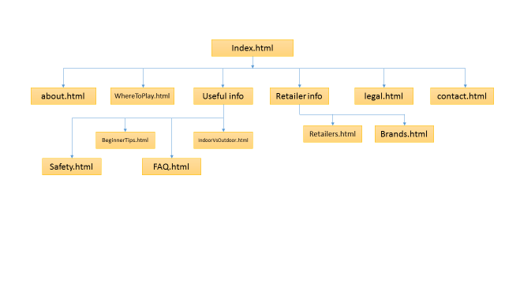 We kept the structure of our website simple, allowing all users to be able to view information as fast and as clearly as possible with it located at the top of the screen, we input the sections mentioned “index”, “Legal information”, “Where to play”, “Safety”, “Retailer info, “Brand info”, we also included a “contact” page with information to contact us and our location on a map

We kept our navigation simple, consistent and complete on all pages.

**Page design** – *Adam and Conor*

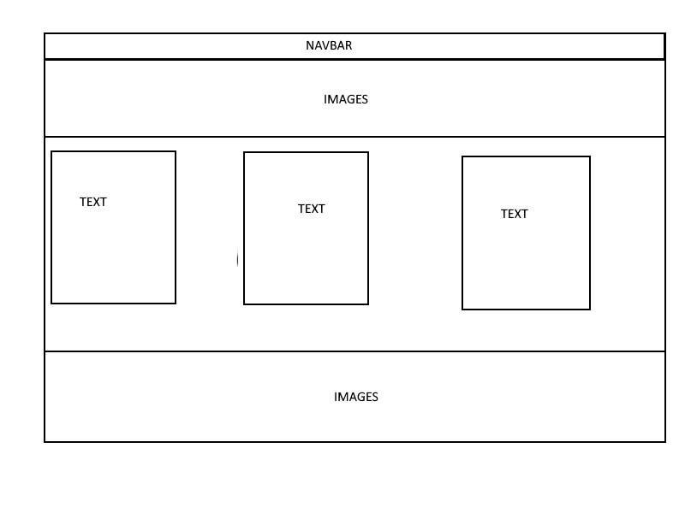

For our page design we wanted it to be mostly image based to draw attention to the topics we were talking about on each page, we used a carousel on the index page to show off a few photographs of airsoft players and equipment immediately upon entering the site we also chose to have boxes with very frequently asked questions that we are asked all the time by first time players, we did this to ease those questions and traffic users into different parts of our site.

At the bottom of the page we decided to show airsoft as a team game, and how it is enjoyed by both young and older, male and female.

We heavily used images with links, most notably within the brand and retailer information, we made this as bright and as recognisable as possible, many of the retailers and brands are known to current airsoft players, but we wanted to draw as much attention off of a new player as possible as this information is viewed as crucial.

We chose to keep our purely informative pages such as out safety page free of images as we didn’t want the user to become distracted from the important information that we wanted them to read, we also kept them short and to the point as not to discourage the user from reading them.

For our Legal information page we realised that we cannot put legal advice down on our website as we don’t have any experience in Irish law, so we gave a link to a very informative laid out document pointing out everything that is currently in Irish law regarding airsoft.

We plan to use pictures of airsoft as a sport, showcasing its team aspects and enjoyment, we also plan to use pictures of brand logos to make our information more recognisable to the public.

We plan to use retailer logos, to display the image of the shop, and hopefully draw a user to follow a link to that website.

As we previously stated, the other airsoft sites that we have looked at, look very dated and tend to have a slow load time.

The over use of colour on those websites tends to be an eyesore, in order to completely eliminate this problem, we went with a modern grey and white colour scheme and tried to keep the pages as minimal as possible without them appearing too bare